Product Name = NEXXUS MI
Product Abbreviation = MI
Product Mark =
Ver Num (Application Version) = 11
Custom (Full Document Title) = EXERCICE BOOK
Doc Type = Training Name
Doc Type Abbreviation = FDD
Doc Name = DocName
Rev Num (Document Version) = 1.0
DocDate = August 11, 2015
Copy Year = 2015
Client Name Full (Prepared For) = For Internal and External Use
Preparer Name Full (Prepared By) = Corporate Training Center
Author = Author
Blank =

NEXXUS MI
Application Version: 11
EXERCICE BOOK
NEXXUSETL STANDARD CONNECTOR
Document Version: 1.0
Publication Date: August 11, 2015
For Internal and External Use
Prepared by: Corporate Training Center
©2015 IMS Health Incorporated and its affiliates. All rights reserved. Trademarks are registered in the United States and in various other countries.The information contained in this document is proprietary and confidential information of IMS Health and its subsidiaries and may not be duplicated,published or disclosed to a third party, in whole or in part, without prior written permission from an authorized IMS Health representative. The useand disclosure of this information are further subject to the terms and conditions of any applicable agreement between the recipient and IMS Health, including any governing service, confidentiality or non-disclosure agreement.
IMS Health
137 rue d'Aguesseau
92641 Boulogne-Billancourt Cedex

Publication Record
Application Version | Doc Version | Publication Date | Author | Document Checker | Overview of Versions
11 | 1.0 | August 11, 2015 | B. Carette |  | Initial publication
11 | 2.0 | October 19, 2015 | B. Carette |  | Adding the participant number in section 3.1.7
Contents
Publication Record 2
1. Context 4
2. GLOBAL OBJECTIVES 5
3. DATALOADING JOBS IN NexxusETL 7
3.1.0 7
3.1.1 7
3.1.2 7
3.1.3 7
3.1.4 7
3.1.5 7
3.1.6 8
3.1.7 8

Context
Read each exercise carefully before beginning.
Complete each exercise one after the other.
NexxusETL user account
Use the login of the Nexxus MI user you granted NexxusETL rights.
The password should be TRAINING
MoveIt credentials
Login: okc_sajema
The trainer will give you the password
Each participant has a number: be sure to use it for the exercises in this document.
Everytime this symbol * appears in the exercises, please add your respective number to the concerned item

GLOBAL OBJECTIVES
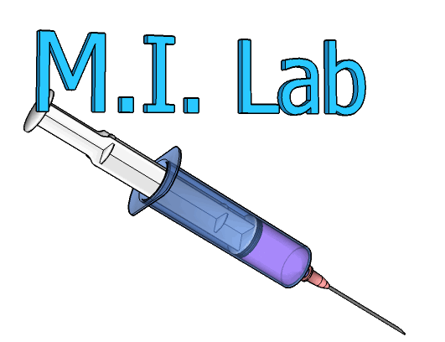

The client M.I. Lab wants to start up his new Nexxus MI project.
Administration elements need to be loaded within the Nexxus MI database.
Standard interfaces will be used in NexxusETL to load the data.

MI Administration
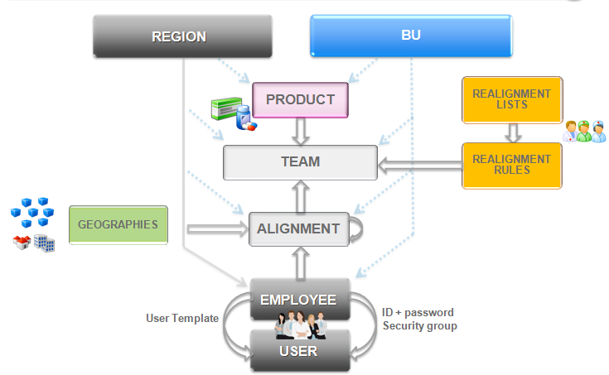

M.I. Lab organization

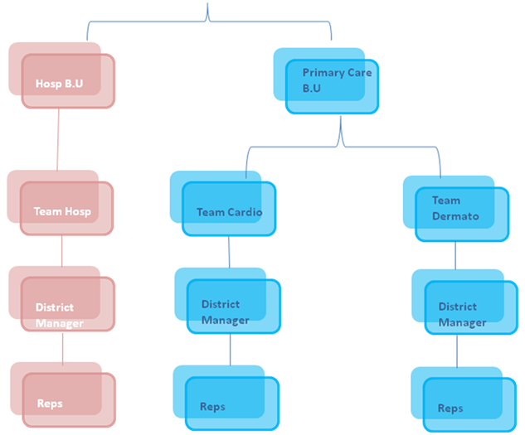

DATALOADING JOBS IN NexxusETL
Ref # | Description
3.1.0 | OBJECTIVE: Load two Business Units  - Hospital (Hosp1)  - Primary Care (PC1)
3.1.1 | OBJECTIVE: Load teams  Using the provided information, load the “Cardiology” and “Dermatology” teams inside the system.  These teams are Specialists ones and belongs to Primary Care Business Unit. Moreover they will be described as “MILab Cardiology” and “MILab Dermatology”. The OTH-DropDownListValues-MI11 document will help you find needful information.  References (Unique identifier) of those teams should be Cardio001 and Dermato001 (Information provided by M.I. Lab).
3.1.2 | OBJECTIVE: Load a District Manager employee and his alignment using MoveIt  Load a DM of Dermatology team called Anton Gilbert. He was born on 15th august 1971 and his I.D will be the first letter of his first name then his last name. Anton’s email is anton.gilbert@milab.com.  Anton Gilbert’s social security number is unavailable so far.  As a District Manager who belongs to Primary Care Business Unit, Anton can drop samples and his alignment name will be AL1.
3.1.3 | OBJECTIVE: Load a Rep and his alignment  Load a rep named Vincent Fournier. His login will be the first letter of his name then his last name. his email will be vincent.fournier@milab.com.  Vincent’s Business unit will be Primary Care and his alignment name will be AL2.  Like Anton Gilbert who is his manager, Vincent will work within Dermatology team.  Anton Gilbert has not decided yet if Vincent will be allowed to drop samples to customers.  Vincent’s social security number is 1 78 02 75 001 01 667 (he was born on 04th february 1978).
3.1.4 | OBJECTIVE: Load Onekey Init  Update the tenant setting to make possible the Onekey dataloading then check on MoveIT if the Init file is available.  Once done, run the proper job from NexxusETL.
3.1.5 | OBJECTIVE: Declare the region of each employee  According to best practices, since Onekey FI format, the region must be declared for all employee of the compagny.
3.1.6 | OBJECTIVE: Explicitely align a OneKey customer  The medical professional Elizabeth Abata (OneKey code WUKM00658330) should be explicitely aligned with Vincent Fournier’s alignement on the 1st day of last month (for both distribution and responsibility).  To do so, use the Customer_Alignment_Timeline interface
3.1.7 | OBJECTIVE: Create a change request  Elizabeth Abata address has changed : instead of “Moorside Road”, she now works in “Bowfell Road”.  From Nexxus MI, give Vincent Fournier a User account (his login will be vfournier* and link it to Default Rep Permissions.  Once it is done, log as Vincent’s account and modify this information (still using Nexxus MI).  Enventually, run the proper job and check the generated archive on the server.

